**PRACTICAL 7**

**COMPUTER ORGANISATION AND ARCHITECTURE**

|  |  |
| --- | --- |
| **NAME: VARUN KHADAYATE** | **ROLL NO: A016** |
| **PROGRAM: BTECH SY** | **DIVISION: CSBS** |
| **BATCH: 1** | **DATE OF EXPERIMENT: 14/10/2020** |

**AIM**

**To Study & Verify Ripple Carry Adder**

**THEORY**

Half Adders can be used to add two one-bit binary numbers. It is also possible to create a logical circuit using multiple full adders to add N-bit binary numbers. Each full adder inputs a Cin, which is the Cout of the previous adder. This kind of adder is a Ripple Carry Adder since each carry bit "ripples" to the next full adder. The first (and only the first) full adder may be replaced by a half adder. The block diagram of 4-bit Ripple Carry Adder is shown here below -

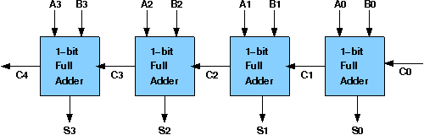

The corresponding boolean expressions are given here to construct a ripple carry adder. In the half adder circuit the sum and carry bits are defined as

sum = A ⊕ B

carry = AB

In the full adder circuit the Sum and Carry output is defined by inputs A, B and Carry in as

Sum=ABC + ABC + ABC + ABC

Carry=ABC + ABC + ABC + ABC

Having these we could design the circuit. But, we first check to see if there are any logically equivalent statements that would lead to a more structured equivalent circuit.

With a little algebraic manipulation, one can see that

Sum= ABC + ABC + ABC + ABC

       = (AB + AB) C + (AB + AB) C

       = (A ⊕ B) C + (A ⊕ B) C

       =A ⊕ B ⊕ C

Carry= ABC + ABC + ABC + ABC

       = AB + (AB + AB) C

       = AB + (A ⊕ B) C

**SIMULATION**

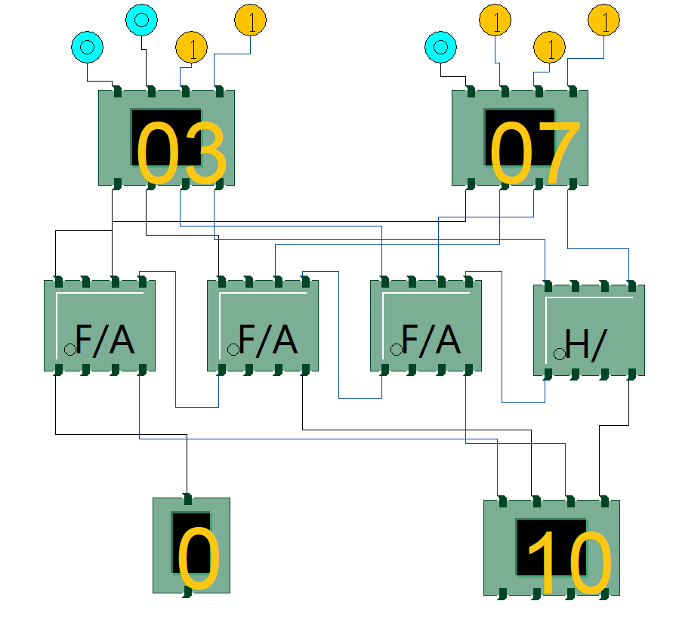

**CONCLUSION**

Hence, we are able to verify ripple carry adder.